Table of Contents
1. Project Rationale 2
1.1 Problem Description 2
1.2 System Explanation 2
1.3 Application of Structured Programming Principles 3
1.4 Relevance to the Sustainable Development Goals 5
2. Open-Source, Data Privacy & Compliance 5
2.1 Open-Source Practices 5
2.2 Data, Privacy & Compliance Considerations 5
3. Conclusion 6
4. Screenshots 7
4.1 System Screenshot 1 — Login Screen 7
4.2 System Screenshot 2 — Management Dashboard 7
4.3 Source Code Screenshot 1 8
4.4 Source Code Screenshot 2 8

1. Project Rationale

1.1 Problem Description
Freetown and other urban centres in Sierra Leone face a persistent and worsening solid-waste management challenge. Household, commercial, and construction waste is frequently left uncollected for extended periods because community members have no formal channel through which to request a pickup, and local sanitation teams have no centralised system for knowing where waste has accumulated, how urgent a request is, or which collection team has been assigned to it. In practice, this means requests are handled informally — through phone calls, word of mouth, or physical visits to a council office — with no record kept of what was promised, what was done, or how long a resident has been waiting.
This lack of a structured tracking mechanism produces several concrete problems. First, there is no way to measure how much waste a community generates by type (household, plastic, organic, electronic, or construction), which makes it difficult for sanitation authorities to plan collection routes or allocate trucks and personnel efficiently. Second, urgent cases — for example, waste posing a health hazard — are not distinguished from routine requests, so they can sit in a queue for days without anyone noticing. Third, because nothing is logged, there is no accountability: a request can become “stuck” indefinitely with no record of who was responsible for acting on it, and no manager can produce evidence of how the service is performing over a given period.
EcoClean SL was designed specifically to close this gap. It gives residents (via municipal staff) a simple way to register a waste collection request, gives field supervisors a queue they can filter and prioritise, and gives management an audit trail and reporting tool to monitor performance over time.

1.2 System Explanation
EcoClean SL is a desktop, GUI-based waste management and collection tracking system built in Python using the tkinter library, in line with the project brief's mandatory requirement for a GUI application (terminal-only submissions are explicitly disallowed). The system is organised around a central in-memory data store of waste collection “requests,” which is persisted to a local data.json file using an atomic write pattern (write to a temporary file, then os.replace) so that the data file cannot be left in a corrupted, half-written state if the program is interrupted mid-save.
The application opens on a login screen and authenticates the user against a small set of demonstration accounts, each tied to one of three roles: Administrator, Supervisor, and Operator. Once logged in, the user is taken to a role-aware dashboard application built around a sidebar of pages. The sidebar itself is generated dynamically: it only displays the buttons for pages that the active role is permitted to open (ROLE_PERMISSIONS), and every page-opening method independently re-checks has_access() before rendering, so a user cannot reach a restricted page even by other means. This is a deliberate security-by-structure decision — access control is enforced at the data/logic layer, not just hidden in the interface.
The functional modules required by the brief are implemented as follows:
- Input Module: the Register Request page collects resident name, phone number, community, waste type (from a fixed dropdown), quantity in kilograms, and priority level, and supports unlimited multiple-record entry through repeated submissions.
- Processing Module: register_request(), update_request_status(), get_dashboard_statistics() and is_overdue() apply validation rules, conditional logic (if/elif/else), and loops (for record in requests_data) to check input, recalculate KPIs, and re-derive each request's status colour-coding every time the data changes.
- Output Module: results are displayed through dashboard KPI cards, colour-tagged Treeview tables (overdue, urgent, completed, pending), a hand-drawn Canvas bar chart of waste-type breakdown, and exportable CSV/TXT reports — all using clear, well-formatted, user-friendly language rather than raw data dumps.
- GUI: every page uses labels, entry fields, dropdowns, buttons (Register, Update, Export, Refresh, Clear, Logout) and a dedicated output/display area, kept deliberately simple, clean and functional rather than decorative.
Beyond the minimum brief, the system adds several quality-of-life features that demonstrate a deeper application of structured design: input validation for phone numbers (minimum digit count) and quantity (must parse as a positive number); status and priority filters on the Collection Queue; click-to-sort table columns shared across three different pages through one reusable helper method (make_sortable / sort_tree_column); an “Assigned To” field so a request can be linked to a named collector or team; automatic flagging of requests that have remained “Pending” for three or more days (OVERDUE_DAYS); a running total of kilograms collected, computed only from completed requests; and an Administrator-only Activity Log that records who performed every single action in the system and when.

1.3 Application of Structured Programming Principles
Structured programming is demonstrated throughout the codebase rather than as an isolated feature. The program is organised as a sequence of small, single-purpose functions and methods (58 in total across the file), each with a clearly descriptive name, which are composed together rather than relying on one large monolithic block of logic. The table below summarises how each required structured-programming element is applied.
Element | Application in EcoClean SL
Variables & Constants | Module-level constants (APP_TITLE, PRIMARY_COLOR, OVERDUE_DAYS, WASTE_TYPES) configure the system in one place; per-record variables (resident_name, quantity, status) hold runtime state.
Data Types | Strings (names, IDs), floats (quantity/KG totals), integers (counters via next_id), booleans (validation results), lists (requests_data, activity_log) and dictionaries (each request record, USER_ACCOUNTS) are all used appropriately.
Decision Structures | if / elif / else chains drive login validation, form validation (register_request), status-colour tagging in the queue, and the dashboard statistics breakdown by status.
Iteration (Loops) | for loops iterate over requests_data and activity_log to search, filter, total kilograms collected, build the community/waste-type breakdowns, and populate every Treeview table in the interface.
User-Defined Functions | Far exceeds the minimum of three: standalone logic functions (register_request, update_request_status, search_requests, get_dashboard_statistics, generate_daily_report, export_csv, is_overdue, is_valid_phone, is_valid_quantity, etc.) are fully separated from the GUI classes, which themselves expose dozens of methods such as build_dashboard(), refresh_records(), make_sortable() and on_status_request_selected().
Modularity | Backend logic (data handling, validation, persistence, reporting) is kept separate from the GUI layer (LoginWindow and EcoCleanApp classes), so the processing functions could be reused or tested independently of tkinter.

This separation of concerns means the GUI classes call into the logic functions rather than embedding business rules inside button callbacks, which keeps each function's responsibility narrow and the overall control flow easy to trace from input, through processing, to output — the core definition of structured programming.

1.4 Relevance to the Sustainable Development Goals
EcoClean SL is aligned primarily with SDG 11: Sustainable Cities and Communities, which calls for inclusive, safe, resilient and sustainable urban management, including the reduction of the adverse environmental impact of cities through better municipal and solid-waste management. By giving Sierra Leonean communities a structured channel to request waste collection, and giving sanitation staff the tools to prioritise, assign, and track those requests to completion, the system directly supports more efficient, accountable urban service delivery.
The project also has secondary relevance to SDG 3: Good Health and Well-Being, since uncollected waste — particularly household and organic waste — is a recognised vector for disease in densely populated urban communities, and to SDG 12: Responsible Consumption and Production, since tracking waste by type (including plastic and electronic waste) is a first step toward better-informed recycling and disposal planning at a municipal level.

2. Open-Source, Data Privacy & Compliance

2.1 Open-Source Practices
The project is published on GitHub under the MIT License, an approved open-source license that permits free reuse, modification, and distribution of the code provided the original copyright notice is retained. The repository includes a README.md describing the system's purpose and setup instructions, full Python source files, and supporting documentation and screenshots as required by the brief.

2.2 Data, Privacy & Compliance Considerations
- Data accessibility: all collected data is stored locally in a single human-readable JSON file (data.json) and can be exported at any time to open, non-proprietary CSV and plain-text formats, so records are never locked into a proprietary format.
- Interoperability: CSV export allows records to be opened in any spreadsheet application (Excel, LibreOffice Calc, Google Sheets) for further analysis by municipal authorities, without requiring access to the original application.
- Basic privacy considerations: the system only collects the minimum personal information needed to fulfil a waste collection request (name, phone number, community); it does not collect or store any sensitive personal data, and access to the full activity/audit trail is restricted to the Administrator role only.
- Ethical use of user data: resident data is used solely to coordinate and track the collection service itself. The Activity Log exists to create accountability for staff actions, not to monitor residents, and every logged action is attributed to the staff member (performed_by) who carried it out rather than to the resident.

3. Conclusion
EcoClean SL demonstrates that the principles of structured programming — clear sequencing, decision structures, iteration, and modular, well-named functions — can be applied to build a genuinely useful, multi-role GUI application that addresses a real infrastructure gap in Sierra Leone. The system is intentionally scoped to remain simple, clean, and functional, in line with the project brief, while still going beyond the minimum requirements in validation, role-based security, and reporting to produce a tool that a real municipal sanitation team could plausibly adopt.

4. Screenshots
The following pages contain the screenshots required by the submission brief: two (2) system screenshots and two (2) source code screenshots. Replace each placeholder box below with the corresponding screenshot before printing or submitting this report.

4.1 System Screenshot 1 — Login Screen
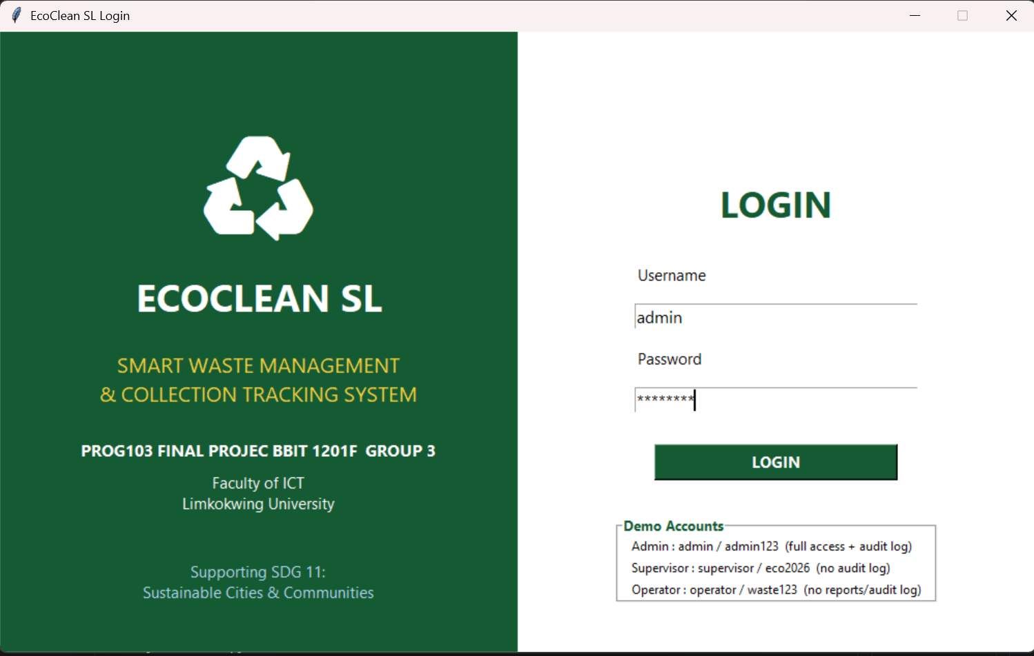

4.2 System Screenshot 2 — Management Dashboard
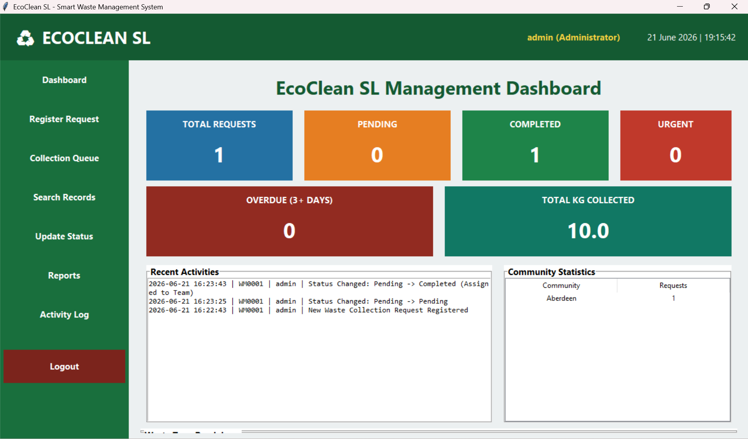

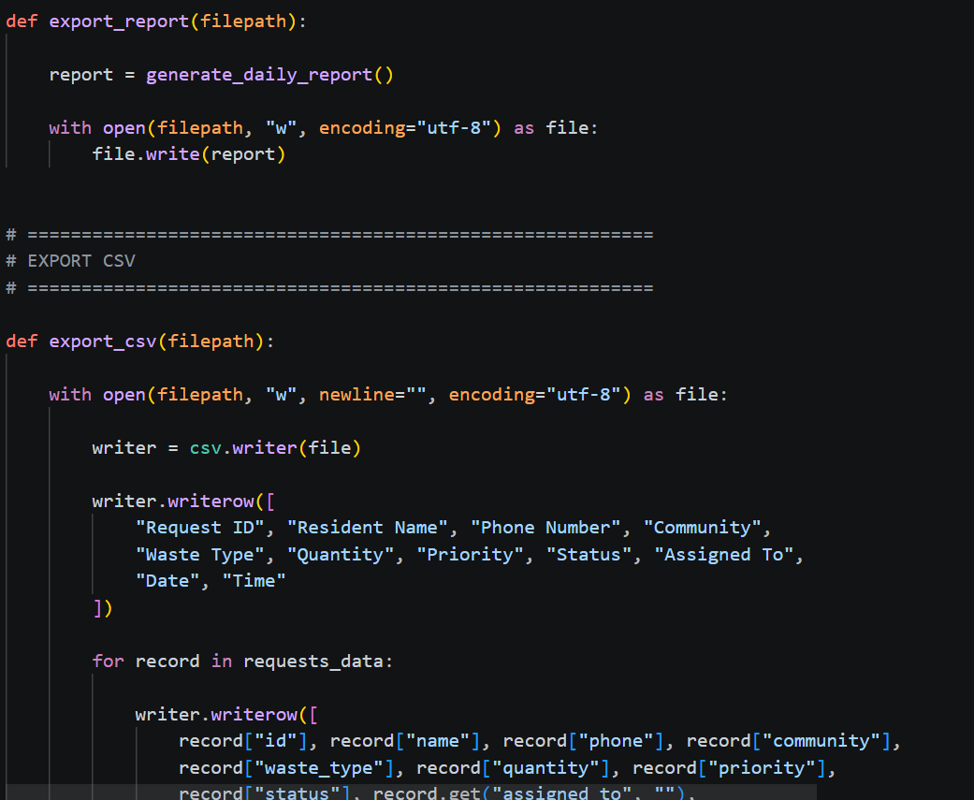
4.3 Source Code Screenshot 1

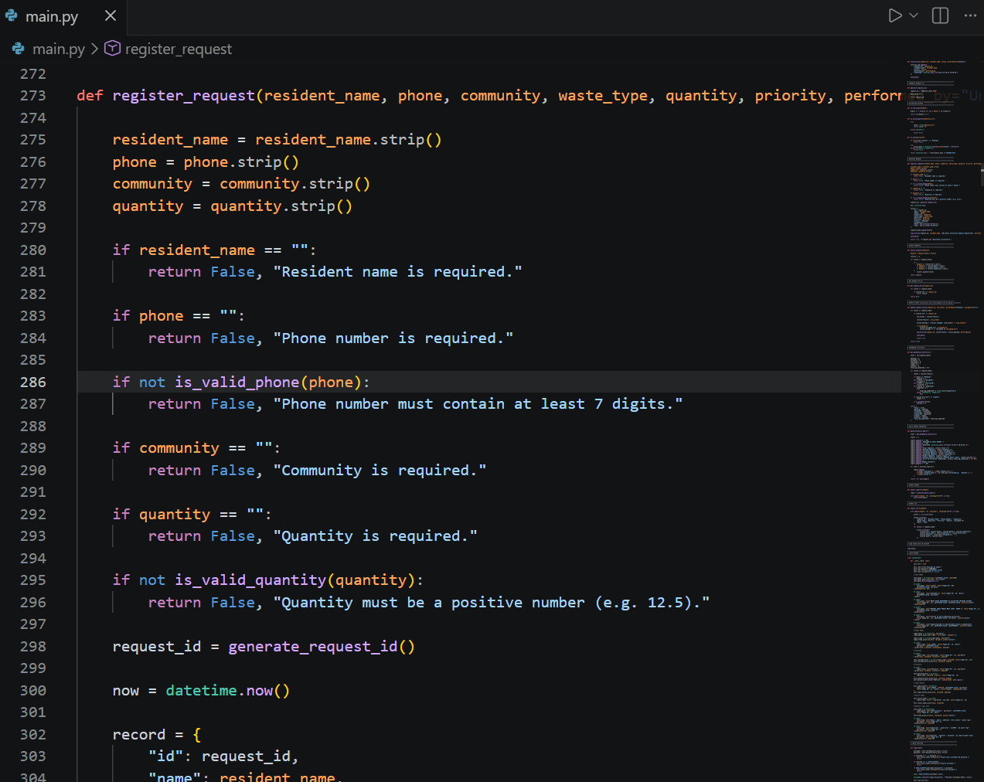

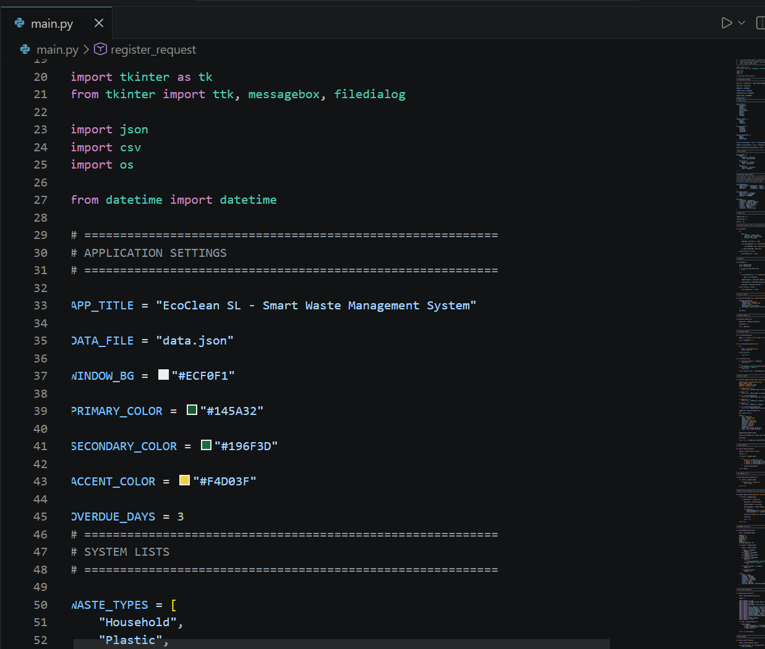
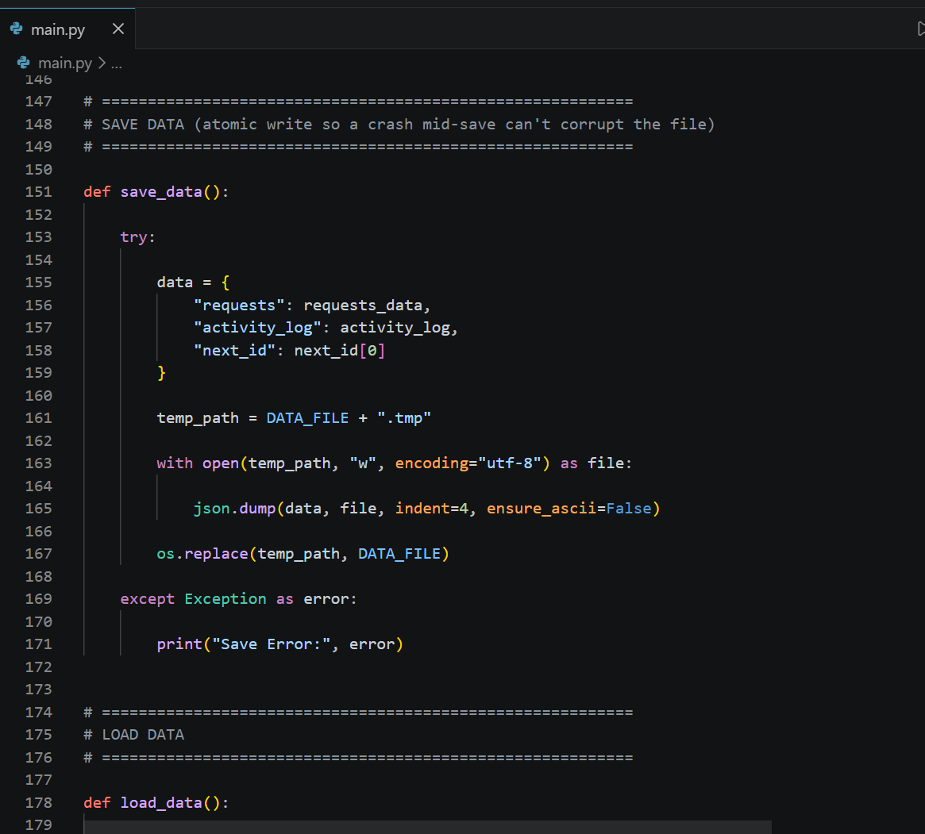
4.4 Source Code Screenshot 2

